What is Docker?

Command:

Docker run

Docker ps

Docker ps -a

Stopped container also will be showing.

2.How to install docker on windows & Linux

Docker images introduction

26-06-2023:

Nano

Vim for editing file.

Docker build

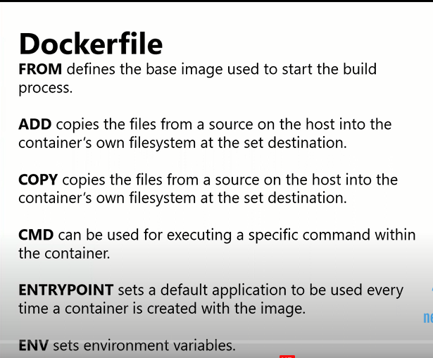

Add – source and destination (Source sometimes URL, google URL, Zip file will extract and that file that feature available )

Copy— source and destination

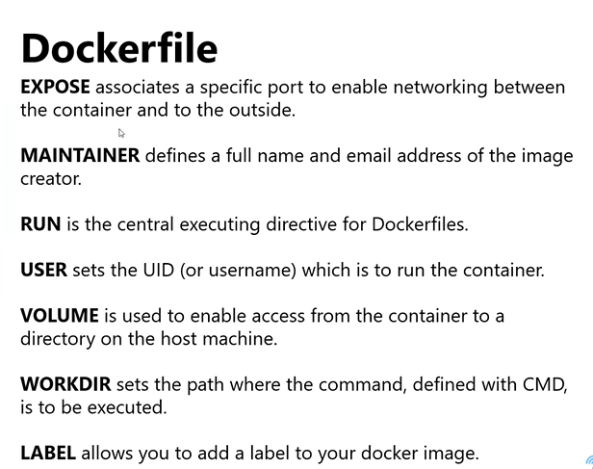

How to create build image

Touch Dockerfile

Plain images will create on container

Commands:

Docker image(checking images available or not)

Docker build -t accountname/imagename .

Docker image

Docker pull image name

Docker run -dt –name

Build chesina artificates integrating with